|  |  |  |  |
| --- | --- | --- | --- |
| **Branch: Instrumentation & Control Engineering** | | **Year:** Second Year | |
| **Division: C** | **Roll No: 04** | **GR Number: 11911180** | **Subject:** OOPS |
| **Assignment No:** | **Date of Submission: 29-04-2021** | **Student Full Name: Shaunak Sudhir Deshpande** | |

Aim: Write a Program to add 2 numbers using 1 parameter, 2 parameter functions. Use concept of function overloading

Software Used: MinGW, VSCode

Code:

#include <iostream>

using namespace std;

class Add

{

    int number1 = 0;

public:

    int sum(int number2)   //Function Overloading

    {

        return number1 + number2;

    }

    int sum(int number1, int number2) //Function Overloading

    {

        return number1 + number2;

    }

};

int main()

{

    Add obj1;

    cout<<"Output (1 parameter): "<<obj1.sum(100)<<endl;

    cout<<"Output (2 parameters): "<<obj1.sum(12, 24)<<endl;

    return 0;

}

Output:

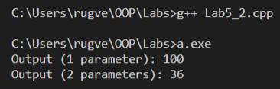

Analysis of Program:

This program is a demonstration of using functional overloading in order to use the same function name for 2 functions with different signatures. It consists of two functions, both called sum(), one which requires only one input and other which requires two inputs.

Conclusion:

Function overloading is the ability to create multiple functions of the same name with different implementations. In this case, we have successfully implemented function overloading and it helps us to use the same name for two different functions, thus adding convenience.